**CIDM 6308 Seminar in Data Analytics Exam 2**

# points; Due 11:59 pm CDT August 10, 2023

**Requirements: This exam is open book, open slides, and open notes. Because this is an individual exam, you are not allowed to collaborate nor discuss with anyone else during the exam period. Sharing anything related to the exam with any person or party violates the University's Academic Integrity Code, as well as the PEV COB Student Code of Ethics listed in our syllabus, and will be reported to the Dean Office of PEV COB. Any question about the exam should be directed to the instructor.**

**Please follow the instruction and requirements to answer all the questions. After completing the exam, please submit your answers via Exam 2 Submission on WTCLASS. It is your responsibility to make your answers meet the required format; otherwise, you would lose points because of wrong format.**

**Exam 2 is designed to help you solve real-world business problems using data analytics techniques that you have learned this semester and it includes six tasks below:**

* Task 1: Theoretical Understanding of Analytics (30 points)
* Task 2: Demonstrating the Importance of Retaining Customers (27 points)
* Task 3: Data Preparation & Exploration (42 points)
* Task 4: Building & Understanding Decision Tree Model in RapidMiner (39 points)
* Task 5: Prediction with Decision Tree and Logistic Regression Models and Model Comparison (32 points)
* Task 6: Social Network Analytics (30 points)

**Datasets**:

* Training.csv, the training set with 5,000 records, used for Task 2, 3, 4, and 5.
* Prediction.csv, the prediction set with 100 records, used for Task 5.

**Software**:

* Excel
* Tableau
* RapidMiner

Our textbook *Data Science for Business* mentions the example of predicting customer churn (a typical application of data analytics) in multiple chapters such as Chapters 1, 3, 5, 8, and 14.

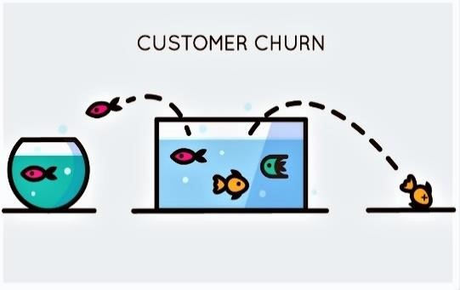Mark just landed a great analytical job with MegaTelCo, one of the largest telecommunication firms in the United States. MegaTelCo provides both wireless and internet services and it has hundreds of millions of customers. They are having a major problem with customer retention in their telecommunication business. Many customers leave, and it is getting increasingly difficult to acquire new customers. Since the telecommunication market is now saturated, the huge growth in the telecommunication market has tapered off. Communications companies are now engaged in battles to attract each other’s customers while retaining their own. Customers switching from one company to another is called customer churn, and it is expensive all around: one company must spend on incentives to attract a customer while another company loses revenue when the customer departs. According to a report, annual churn rates for telecommunications companies average between 10% and 67% ([Database Marketing Institute, 2008)](http://www.dbmarketing.com/telecom/churnreduction.html#:~:text=Wireless%20companies%20today%20measure%20voluntary,10%20percent%20and%2067%20percent.). Customer churn not only increases operation and advertising cost, but also reduces revenue and damages brand image.

As Computer Weekly cites, mobile operators spend approximately 15 percent of their revenues on network infrastructure and IT — but a whopping 15 to 20 percent of revenues on the acquisition and retention of customers [(Computers Weekly, 2018)](https://www.computerweekly.com/blog/The-Full-Spectrum/How-churn-is-breaking-the-telecoms-market-and-what-service-providers-can-do-about-it).

It’s long been known retention of existing customers is less expensive than acquisition of new ones. In fact, a Canadian study found it costs nearly 50 times less to retain than acquire [(Telecoms, 2018)](https://telecoms.com/opinion/churn-is-breaking-the-telecoms-market-heres-how-to-fix-it/). Therefore, a good deal of marketing budget is allocated to prevent customer churn. The Marketing department is going to designate a special retention offer. Mark’s task is to devise a precise, step-by-step plan for how the data science team should use MegaTelCo’s vast data resources to predict whether or not a particular customer is going to turn over before s/he actually leave so that MegaTelCo can offer the special retention deal to prevent customer churn. This is even more important to retain high-value customers. In order to predict customer churn, Mark and his data science team need to apply data analytics techniques (esp., data mining). In order to solve this problem, Mark plans to take the data on prior churn and extract patterns, for example, patterns of behavior, that are useful—that can help him to predict those customers who are more likely to leave in the future, or that can help us to design better services.

Considering that it is very time-consuming to download and process millions of records, Mark decides to start with building data mining models via a portion of the data via a random sampling technique (See Chapter 8 in Dr. B’s book). Using the database querying technique, Mark obtains a random sample of 5000 records (i.e., customers) from the company’s data repository.

Next, Mark prepares the data for initial analysis: First, as the dataset has hundreds of attributes, Mark applies feature selection techniques to include a small number of important attributes in his initial models, rather than all the attributes. Next, Mark cleans the data to solve the quality issues of the data such as missing or extreme values. Finally, Mark obtains a cleaned dataset with 13 predictor attributes (or variables) from three categories (see the table as below) and one target attribute (i.e., the attribute of our interest, also called dependent attribute in statistics).

**Attributes and Their Description**

|  |  |  |  |
| --- | --- | --- | --- |
| Category | Attribute Name | Description | Values |
| Demographic Information | CustomerID | A Unique ID to identify each customer | Format: NNNN-LLLLL |
| Gender | The gender of each customer | Male/Female |
| SeniorCitizen | Whether or not a customer was a senior citizen | 1=yes, 0=no |
| Partner | Whether or not a customer had a partner | Yes/No |
| Dependents | Whether or not a customer had dependent(s) | Yes/No |
| Tenure | The length of time (in months) a customer had stayed with the company | Whole number |
| Service  Information | PhoneService | Whether or not a customer had phone service | Yes/No |
| InternetService | What type of internet service a customer had (code No if a customer had no internet service) | DSL/Fiber/No |
| Account  Information | Contract | The contract type that a customer had with the company | Month-to-Month/ One Year/ Two Year |
| PaperlessBilling | Whether or not a customer used paperless billing | Yes/No |
| PaymentMethod | The payment method that a customer used | Electronic Check Mailed Check credit Card (auto) Bank Transfer (auto) |
| MonthlyCharges | The total monthly payment a customer made | Real number |
| TotalCharges | The total life-to-date value/revenue a customer contributed | Real number |
| Target | Churn | Whether or not a customer churned last month | Yes/No |

In Exam 1 Part 2, you helped Mark gain a good theoretical understanding of this case and explored the data and the relationship between other attributes and the target attribute, churn. In Exam 2, you are going to continue to help him work on this case using multiple data analytics techniques to accomplish the following four goals:

1) Demonstrating the importance of retaining customers 2) Preparing and exploring the data before modeling.

1. Building a decision model to predict whether or not a particular customer is going to turn over.
2. Making predictions with decision tree and logistic regression models and comparing their results.

In order to achieve the goals above, you are going to apply data analytics techniques that you have learned from the course Data Analytics Seminar at WTAMU.

1. **Understanding Analytics Concepts & Principles (30 points)**

In the past few weeks, we have introduced a list of important analytics methods, concepts, and principles. Please indicate whether each of the 15 statements on WTCLASS is true or false by typing T or F in the front (30 points).

1. **Demonstrating the Importance of Retaining Customers (27 points)**

In order to demonstrate the Importance of Retaining Customers, you want to use the attribute Tenure in your dataset. It is well-known that a customer with a longer tenure is more loyal and contributes more total revenue to the company. In this case, you want to examine whether customers with a longer tenure pay more each month. Here, you are not analyzing each individual customer, but customers at each tenure level. In Tableau, you are going to generate a line chart to show the relationship between tenure and the average monthly charges of all the customers at each tenure level.

* 1. Import the data into Tableau.

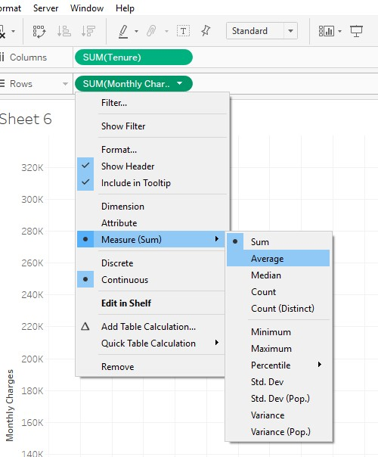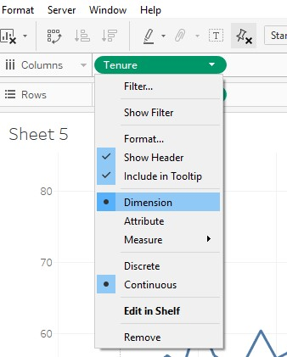

* 1. Drag Tenure and MonthlyCharges to the Columns and Rows, respectively.
  2. Change the measure of

Monthly Charges to

Average

* 1. Change Tenure to Dimension and then you will see a line chart

* 1. This line chart shows the pattern between tenure and the average monthly charges of all the customers in each tenure period. Overall, the line chart has an increasing trend with some fluctuation. Click “View Data” and you will see the dataset displayed by the line chart (Note: your dataset may be different from the one provided below as we generate a different random sample each time).

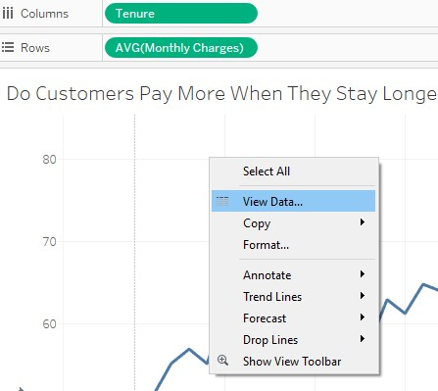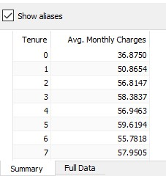

* 1. As you see, the dataset is displayed in Summary does not have 5,000 records because customers at each tenure level (e.g., 6 months) are cumulated/summarized into one data point to represent their average monthly charges. Even though the data here has a smaller granularity (less granular), it can help us answer the question whether or not customers would pay more as they stay longer in a company. View the data (Summary) and the line chart, and then answer the following questions (9 points in total, 3 points for each blank; type whole numbers only):
     1. How many records does the dataset (Summary) have? 5000
     2. The Avg. Monthly Charges is greatest when Tenure = 72
     3. The Avg. Monthly Charges is smallest when Tenure = 43

* 1. Click Analytics pane and drag the default Trend Line to your line chart (the default trendline in Tableau a linear regression model).
  2. When moving your cursor to your trendline, you will see your trendline model. Based on the trendline model and what you learned in Class 8, please answer the following questions (18 points in total and 3 points for each blank). Round your answers to the second decimal place such as 0.12.
     1. You see a regression model with the trendline. Please complete the model as below: Average Monthly Charges = 0.29× Tenure + 55.00
     2. This linear regression model suggests that when a customer’s tenure increases by five months, their monthly charge will increase by 56.45 dollars (You must type a positive number here).
     3. You find R2 (R Squared) = 0.69
     4. According to Class 8 Lecture, R2 is important measure of the goodness of fit of a linear regression model. In simple linear regression (there is only one independent variable), the square of the correlation between the dependent variable and the explanatory variable. Please use R2 to compute the correlation coefficient between tenure and average monthly charges. Their correlation coefficient = 0.83
     5. Finally, the p-value indicates that this regression model is quite significant, based on what you have learned from Class 8 Lab.
  3. You may observe some meaningful patterns from the chart. Based on what you observe, please think about why it is important to retain customers.

1. **Data Preparation & Exploration (42 points)** 
   1. There are three numerical attributes in our dataset, Tenure, Monthly Charges, and Total Charges. We are going to see if there is any redundant or highly-correlated attribute there. Please compute the correlation coefficients between any two of the three attributes (12 points in total and 3 points for each blank). Round your answers to the second decimal place such as 0.34.
      * + The correlation coefficient between Tenure and Monthly Charges is 0.06 Note: This correlation is different from the one in Step 2.3.3 because they have different units of analysis (UOA): UOA in Step 2.3.3 is customer group while here the UOA is individual customers.
        + The correlation coefficient between Tenure and Total Charges is 0.66
        + The correlation coefficient between Monthly Charges and Total Charges is 0.47
        + Two attributes are highly correlated when the absolute value of their correlation coefficient is greater 0.85. In this case, how many pairs of attributes are highly correlated? Type a whole number here. 0

* 1. Mark wants to explore how many clusters those customers naturally form using the k-means clustering. He tries to figure out how k-means clustering works before running it on RM. The two variables, Tenure and Monthly Charges, are used for clustering customers into four clusters. After a particular iteration, the centroid of each cluster is computed below (Tenure, Monthly Charges):
     + - Cluster 1 (11,32): Tenure =11 months, Monthly Charges =$32
       - Cluster 2 (52, 33): Tenure =52 months, Monthly Charges =$33
       - Cluster 3 (20, 81): Tenure =20 months, Monthly Charges =$81
       - Cluster 4 (64, 93): Tenure =64 months, Monthly Charges =$93

Next, he needs to compute the distance from each data point (i.e., a customer) to each centroid above to determine to which cluster each data point belongs. In order to illustrate k-means algorithms to others, he uses a customer (i.e., a data point) with a tenure of 38 months and $95 in monthly charges (38, 95) as an example (30 points).

* + 1. He first computes the Manhattan distance from this data point to each centroid. Type a whole number in each blank.
       - The Manhattan distance from this specific data point to the centroid of Cluster 1 is 90.
       - The C2 is 76
       - The Manhattan distance from this specific data point to the centroid of Cluster 3 is 32
       - The Manhattan distance from this specific data point to the centroid of Cluster 4 is 28
       - Based on the four distances above, this specific customer will be assigned to Cluster 4
    2. He then computes the Euclidian distance from this data point to each centroid. Round each distance to a whole number.
       - The Euclidian distance from this specific data point to the centroid of Cluster 1 is 69
       - The Euclidian distance from this specific data point to the centroid of Cluster 2 is 64
       - The Euclidian distance from this specific data point to the centroid of Cluster 3 is 23
       - The Euclidian distance from this specific data point to the centroid of Cluster 4 is 26 • Based on the four distances above, this specific customer will be assigned to Cluster 3
    3. Do the two distance measures (Manhattan distance and Euclidian distance) assign the same cluster to this data point? No

1. **Building & Understanding Decision Tree Model in RapidMiner (39 points)** 
   1. Import the data to RapidMiner (You may follow Class 8 Lab).
   2. Suppose that no highly-correlated attributes are identified in Step 3.1. We just need to unselect an irrelevant attribute (i.e., Customer ID) using an operator in RapidMiner (you may refer to Class 7 Lab for this operator). You must remove this attribute in RapidMiner using this operator, instead of manually removing it in Excel.
   3. Set your target attribute.
   4. Develop a decision tree model using the specified parameters below.
   5. 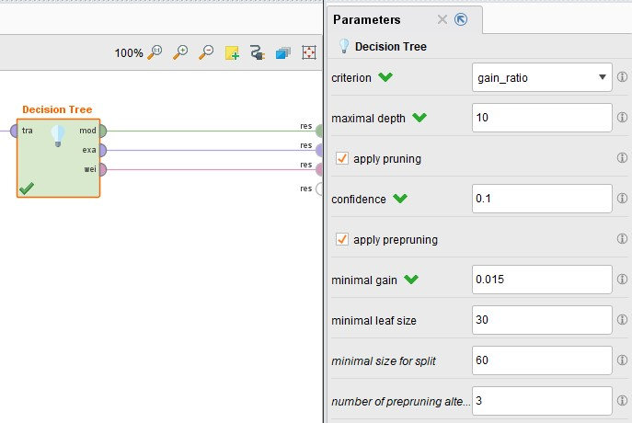Here, you are requested to provide three outputs: model, example set, and weights. We learned the first two outputs in our previous lab. The third output (weights) represents the feature importance for each given attribute. A weight is given by the sum of improvements the selection of a given attribute provided at a node. The amount of improvement is dependent on the chosen criterion. The higher the weight of a given attribute, the more important or informative it is in the decision tree model. This can be used to identify the strong differentiators that we discussed in Exam 1 Part 2.
   6. Save your RM process and then run it.
   7. After running the process, please observe your decision tree model and then answer the following questions (21 points in total and 3 points for each). Type a whole number in each blank unless otherwise stated.
      1. Excluding the root node, how many split nodes in this tree?5
      2. Among all the leaf nodes, 3 are labeled as Yes and 5 are labeled as No.
      3. Among all the leaf nodes, how many of them is 100% pure (i.e., single color in the leaf node)? 0
      4. How many leaf nodes have more than 1000 items (records)? 1
      5. One leaf node has the largest size (the largest number of items). How many items are included in this leaf node? 1154 Which class is this leaf node labeled as, Yes or No? No
   8. Sort Attribute Weight Output by the weight in descending order and then answer the following questions (9 points in total and 3 points for each):
      1. Which attribute has the highest weight? Type the attribute name here. _________
      2. The weight of this attribute is ______ (Round to the second decimal place).
      3. Is this attribute also the root node in your decision tree graph? Type Yes or No here. _________

* 1. Please use the decision tree to determine whether the following customers would churn (9 points in total and 3 points for each blank):

|  |  |  |  |  |  |  |  |  |  |  |  |
| --- | --- | --- | --- | --- | --- | --- | --- | --- | --- | --- | --- |
| gender | SeniorCitizen | Partner | Dependents | tenure | PhoneService | InternetService | Contract | PaperlessBilling | PaymentMethod | MonthlyCharges | TotalCharges |
| Male | 1 | Yes | Yes | 12 | Yes | Fiber optic | One year | Yes | Mailed check | 56.05 | 678.30 |
| Female | 0 | Yes | No | 2 | No | No | Monthto-  month | No | Bank transfer (auto) | 98.25 | 196.50 |
| Male | 0 | No | No | 39 | Yes | DSL | Two year | Yes | Credit card (automatic) | 53.85 | 2200.7 |

1. **Prediction with Decision Tree and Logistic Regression Models and Model Comparison (32 points)**

Now, you are asked to predict whether or not 100 new customers (stored in Prediciton.csv) will churn using both decision tree and logistic regression models in an RM process. The Logistic Regression operator in the new version of RM is getting more powerful as it can automatically handle binomial string attribute *Churn* and recode nominal or categorical attributes to dummy attributes. Accordingly, you do not need to transform Yes and No to 1 and 0, respectively. If you do not know how to allow two operators to use the same dataset (training or prediction), you can refer to an example in the Appendix at page 11.

* 1. Use the decision tree model you built in Step 4 for prediction.
  2. Develop a logistic regression model for prediction with the specified parameters of the Logistic Regression operator below (the specified parameters are default, but just in case that your default is different from mine, please double check).

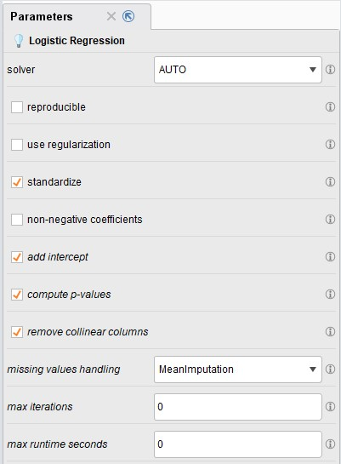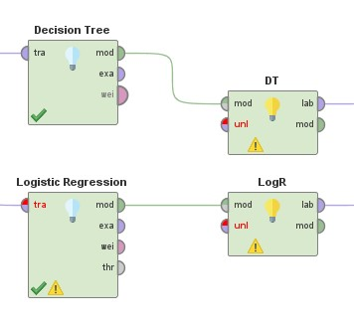

* 1. In order to distinguish the prediction results of the two models, please change the name of Apply Model for the decision tree model and logistic regression model as DT and LogR respectively.
  2. Run your process to generate two predictions results: one from the decision tree model and the other one from the logistic regression model.

* 1. Take a look at the statistics view of the prediction results from your decision tree model and logistic regression model. An example from another project is provided below.

Note: The example below is used to help you understand the statistics of the three attributes: Prediction and two Confidence values. For the two confidence attributes, you can see how they are distributed and summary statistics such as min, max, or average, standard deviation. Ideally, we hope that the confidence, i.e., the estimated probability of being in any class, is equal or close to 0 or 1 (i.e., the two ends in the histogram). As shown in the two histograms above, almost all the confidence values are located at the both extremes, indicating that the overall prediction results are quite confident. In order to better evaluate and compare prediction performance of various models, you can either find online materials, read our textbook (Chapters 7 and 8), and/or take CIDM 6355 Data Mining Methods (offered each Fall).

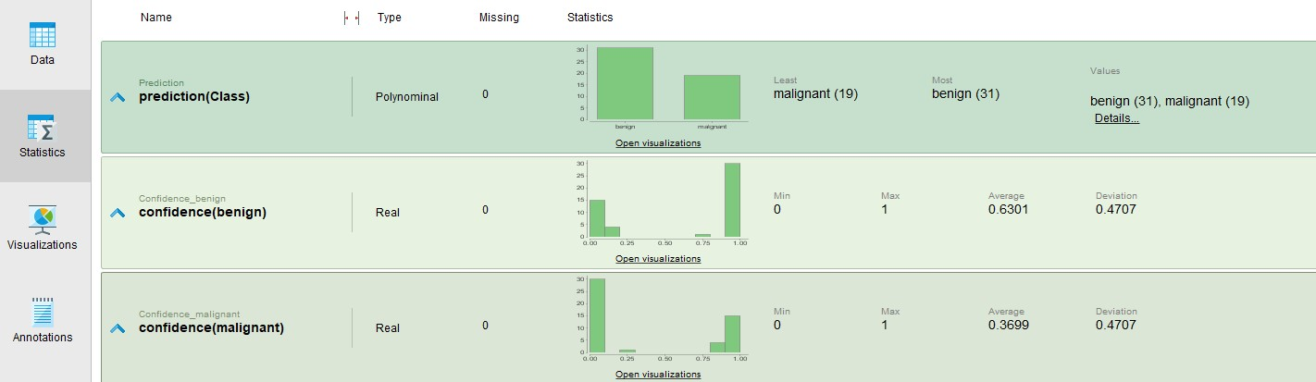

* 1. Based on the statistics views above, please answer the following questions (24 points in total and 4 points for each blank):
     1. For decision tree model, 43 customers are predicted to churn (i.e., Churn = Yes). Type a whole number here.
     2. For the decision tree model, the maximum confidence of not churning (i.e., confidence(No)) is 57 (round to the third decimal place).
     3. For the decision tree model, the maximum confidence of churning (i.e., confidence(Yes)) is 0.568 (round to the third decimal place).
     4. For logistic regression model, 24customers are predicted to churn (i.e., Churn = Yes). Type a whole number here.
     5. For the logistic regression model, the maximum confidence of not churning (i.e., confidence(No)) is 76 (round to the third decimal place).
     6. For the logistic regression model, the maximum confidence of churning (i.e., confidence(Yes)) is 0.779 (round to the third decimal place).
  2. As mentioned in the note above, we try to avoid any uncertain predictions. In our case, the target attribute is a binary, Yes or No. Therefore, the confidence (Yes) = 1 – confidence (No). We decide to drop the prediction for those records with a confidence between 0.4 and 0.6 (excluding 0.4 and 0.6). Please answer the following questions (8 points in total and 4 points for each; Type whole numbers only):
     1. How many predictions from the decision tree model will be dropped because of high uncertainty? 43
     2. How many predictions from the logistic regression model will be dropped because of high uncertainty? 31

Note: You can either manually count the number by sorting confidence (Yes) or confidence (No) or add one more operator “Drop Uncertain Predictions” with the specified parameters below.

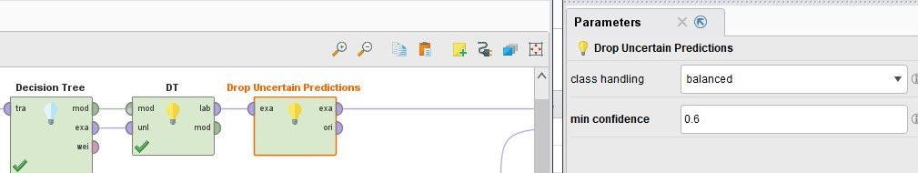

1. **Social Network Analytics (30 points)** 
   1. After performing social network analytics, Mark finds that there are many networks among those customers based on their phone call records. After doing some research, he realizes that network measures such as density and centrality can also influence customer churn. In order to understand those measures, he explores ten undirected networks below.

|  |  |  |  |  |  |
| --- | --- | --- | --- | --- | --- |
| Network | # of Customers | # of Connections | # of Churned customers | Network Density | Churn Rate |
| 1 | 35 | 200 | 11 |  | 0.31 |
| 2 | 39 | 384 | 9 |  |  |
| 3 | 40 | 339 | 10 |  |  |
| 4 | 33 | 95 | 14 |  |  |
| 5 | 36 | 316 | 13 |  |  |
| 6 | 31 | 359 | 5 |  |  |
| 7 | 37 | 368 | 8 |  |  |
| 8 | 32 | 344 | 4 |  |  |
| 9 | 38 | 305 | 11 |  |  |
| 10 | 34 | 205 | 7 |  |  |

* 1. In the table, the first column represents the network number, the second column shows the number of customers in each network, the third column describes the total number of connections within each network, and the fourth column indicates the number of customers who have churned (i.e., churn = Yes) for each respective network. You need to compute the final two columns. For example, Network 1 has 35 customers and 200 connections based on their phone call records, and 11 out of the 35 customers churn (with churn = yes in the dataset). You can use what you have learned from Class 9 to compute this network’s density and then use the fourth column divided by the second column to compute churn rate of this network (11/35=0.31). Repeat this process for the rest nine networks. You are recommended to do this in Excel. Then, please answer the following questions (3 points for each blank):
     1. Which network has the largest density? 4 What is its density score? .35
     2. Which network has the smallest density? 6 What is its density score? 0.09
     3. Which network has the highest churn rate? 4 What is its churn rate? .42
     4. Which network has the smallest churn rate? 8 What is its churn rate? .13
     5. Please compute the correlation coefficient between network density and churn rate. .72
     6. Based on the correlation coefficient above, please indicate the relationship between network density and churn rate: as the value of network density increases, the value of the churn rate increases

# Appendix

When trying to connect the operator for the second model with the

ExampleSet

, a “multiply” sign

appears. When you click it, the Multiply operator

will be

generated.

Doing so, an independent copy of

the same dataset will be created and then delivered to the next operator.

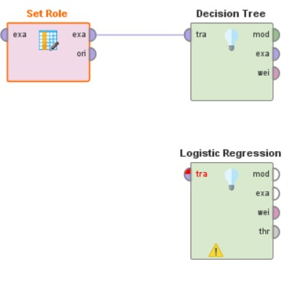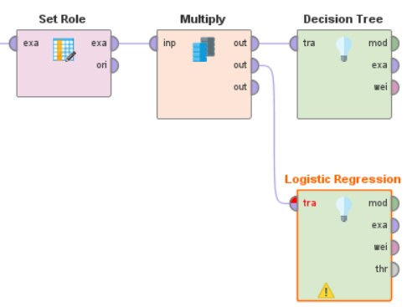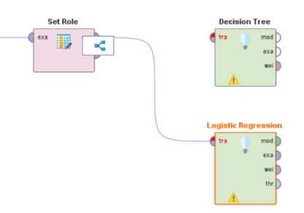

The Multiply operator takes the RapidMiner Object from the input port and delivers copies of it to the output ports. In this case, the example set is copied so that both Decision Tree and Logistic Regression can use the example set.